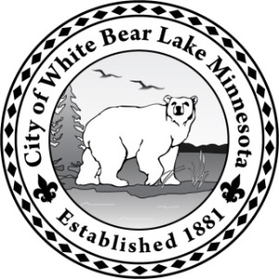**City of White Bear Lake**

Finance Department

***M E M O R A N D U M***

**To:** Ellen Hiniker, City Manager

**From:** Kerri Kindsvater, Finance Director

**Date:**  June 25, 2019

**Subject:** **Bond Sale Report**

**BACKGROUND**

The City Council approved the sale of $4,880,000 in bonds to finance the 2020 street construction projects, the water tower painting project and the purchase of a fire ladder truck and Public Works dump truck at the May 12, 2020 meeting. The approval also directed staff to work with Ehlers in securing a bond sale rating and actively seeking bids for the bonds.

**BOND SALE RATING**

As noted in a memo to the City Council in the current agenda packet, S&P Global Ratings assigned its AA+ long-term rating to the City of White Bear Lake’s general obligation (GO) bonds, series 2020A and affirmed their AA+ long-term rating on the city’s outstanding GO debt.

**BOND SALE RESULTS**

Five investments firms submitted bids for the city bonds. The bids were as follows:

|  |  |
| --- | --- |
| Bidder: | True Interest Cost on Bid: |
|  |  |
| BAIRD; Milwaukee, WI | 1.4007% |
| FHN Financial Capital Markets; Memphis, TN | 1.4127% |
| Stifel, Nicolaus; Birmingham, AL | 1.4147% |
| Northland Securities, Inc; Minneapolis, MN | 1.4473% |
| Raymond James & Associates, Inc; Memphis, TN | 1.4588% |

As shown in the table above, the top three bids are very competitive as the difference between the low and high bids is only 0.0140% for the bond issue.

The bid from BAIRD is 96 basis points lower than the original projection prepared by Ehlers and Associates. BAIRD’s bid includes a premium component, which allows the City to reduce the bond issue amount from the original $4,880,000 to $4,440,000. This adjustment decreases the total principal and interest amount due by $598,135 over the life of the bond, which lowers the average annual levy requirement each year.

The City received competitive bids at a much lower interest rate than originally anticipated due to its good bond rating and timing of the sale. This week there is high demand for municipal general obligation bonds due to the volatile stock market and a lower volume of bonds available for sale.

Below are schedules comparing the original bond sale estimates provided to the City Council on May 12, 2020 and the actual information from the bid opening.

**Preliminary Estimates as of May 12, 2020:**





**Actual Information June 23, 2020**





**RECOMMENDATION**

Staff recommends approval a resolution awarding the sale of the General Obligation Bonds, Series 2020A in the adjusted aggregate principal amount of $4,440,000.

**ATTACHMENTS**

$4.440 Million Series 2020A Sales Report

Resolution